Venu C P

[Email address]

Abstract

[Draw your reader in with an engaging abstract. It is typically a short summary of the document.   
When you’re ready to add your content, just click here and start typing.]

HTML and CSS Assignment

HPEL Boot camp exercise

1. Develop html page that looks similar to the image below. Use HTML tags and CSS to arrive at the solution

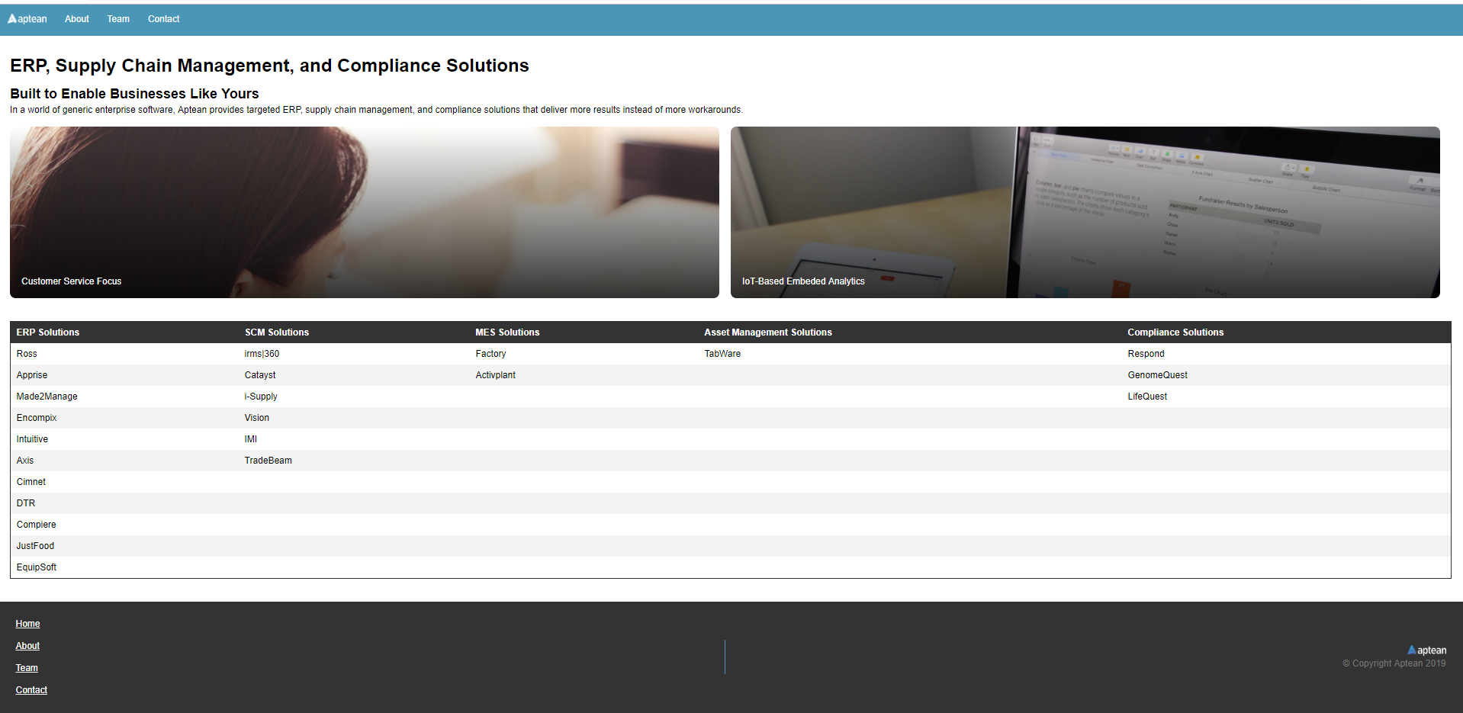

Below are the images that could be used (in Page 2)

|  |
| --- |
| - Aptean logo appearing on the top left corner of the image |
| Aptean logo appearing at the bottom right section in the image |
| Customer Service Focus image |
| IoT Based Embedded Analytics image |